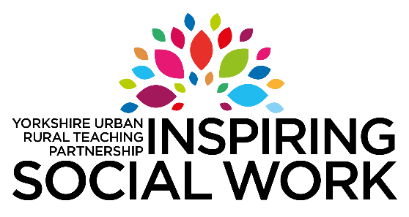

Children and Young People’s Experience of the Social Care System

Young people in Calderdale have been sharing their experiences of the social care system. Supported by Calderdale council they have produced posters and audio clips.

The following 2 groups worked to produce these resources:-
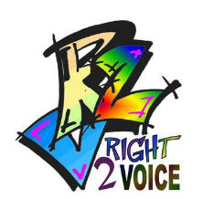
Right to Voice is a forum for children looked after, to come together and work on issues that affect them and their peers. They work on specific projects, are consulted regularly, write newsletters, consult others, attend events and regularly meet with managers within the Council to express their views on things that are important to them as teenagers.
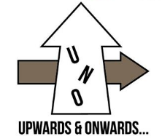
Upwards N Onwards (UnO) are a specific participation group that works to represent children and young people accessing the leaving care service. Using their own voice and representing others they undertake a variety of influence work.

Resources

 | Posters | Audio Clips
Contact
Time
Our Stuff’s Not Trash
Life Stories
No Placement Like Home

