Balloon and basket model (Olivant, 2022)
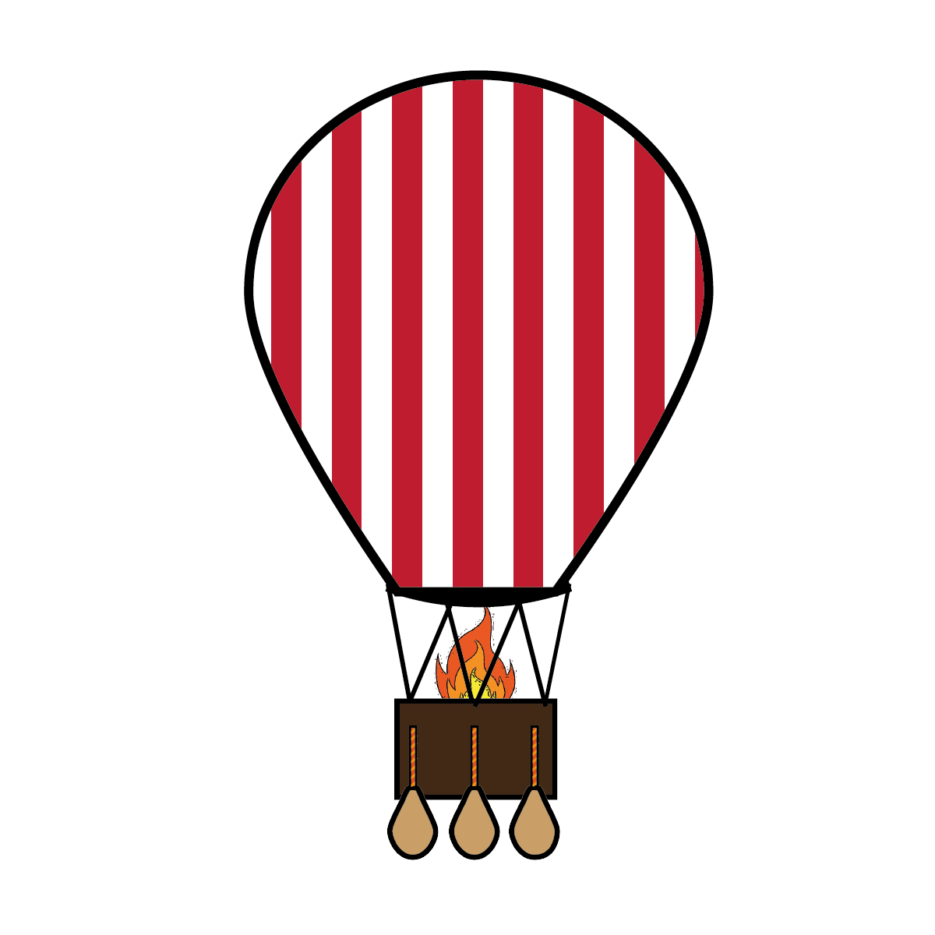
Basket: What is holding you back?
What is preventing you from achieving?
What is weighing you down?
What needs to change in order to remove some ‘sandbags’?
What is within your control?
Balloon: What helps keep you up?
What strengths do you have that help you fly high?
What motivates you to keep going?
What else supports you to stay afloat?

