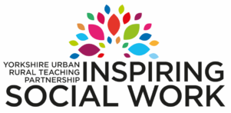

**Governance Model**

**Partnership Board – meets quarterly**

Chair: Samantha Clayton, North Yorkshire County Council

Assistant Director (Social Care) representatives - Local Authorities

Head/Deputy-Head of Social Work – Universities

PSW & WFD Leads – Kirklees/Local Authorities

Subject Leaders – Pre and post qualifying degree courses - Huddersfield & York Universities

Service user and carer representatives from HEI groups

**Curriculum and Co-Production Workstream**

Chair: Ed Robson, University of York

**Teaching Partnership Project Support**

Calderdale Metropolitan Borough Council

Reports to Partnership Board

Supports with Finance, Website, Communications and Co-ordination

**Placements and Practice Workstream**

Chair: Emma Morgan, North Yorkshire County Council

**Partnership and Planning Workstream**

Forms part of Quarterly Board Meetings